**ÍNDICE**

Contenido

1. Introducción del curso: 1

1.1. Link del curso: 1

1.2. Link para descargar el código: 1

2. The Certificate Chain was issued by an authority that is not trusted. 1

2.1. Link 1

3. Fix error: ""The certificate chain was issued by an authority that is not trusted" 2

3.1. Link 2

3.2. Código: 2

4. FREE HOSTING 2

4.1. Link 2

5. Para conectar la base de dato SQL con VISUAL STUDIO 2

COMO HACER UN INDICE AUTOMATICO Y VINCULADO EN WORD: <https://youtu.be/wpjZ7riB21M>

# Introducción del curso:

## Link del curso:

<https://youtu.be/dhguXv3vRIk>

## Link para descargar el código:

<https://github.com/InfoToolsSV/CRUD-ASP.NET-CORE-MVC-.NET-6>

# The Certificate Chain was issued by an authority that is not trusted.



## Link

<https://youtu.be/QJ2h9-PrLXQ>

# Fix error: ""The certificate chain was issued by an authority that is not trusted"



## Link

<https://youtu.be/GT8qWcfhVbE>

## Código:

Scaffold-DbContext "server=DESKTOP-DBHICFF\SQLEXPRESS; database=MVCCRUD;Trusted_Connection=True; Encrypt=False; integrated security=true;" Microsoft.EntityFrameworkCore.SqlServer -OutPutDir Models

# FREE HOSTING



## Link

<https://youtu.be/XvtQsJxhYts>

# Para conectar la base de dato SQL con VISUAL STUDIO

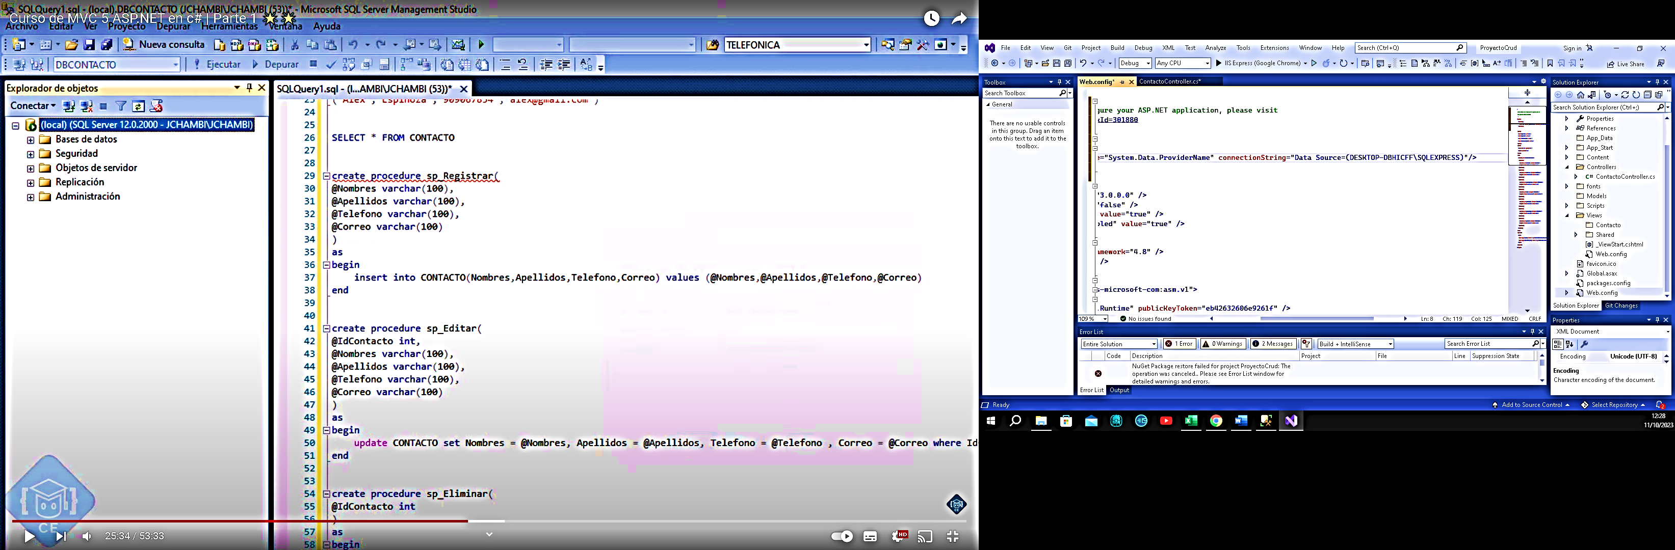

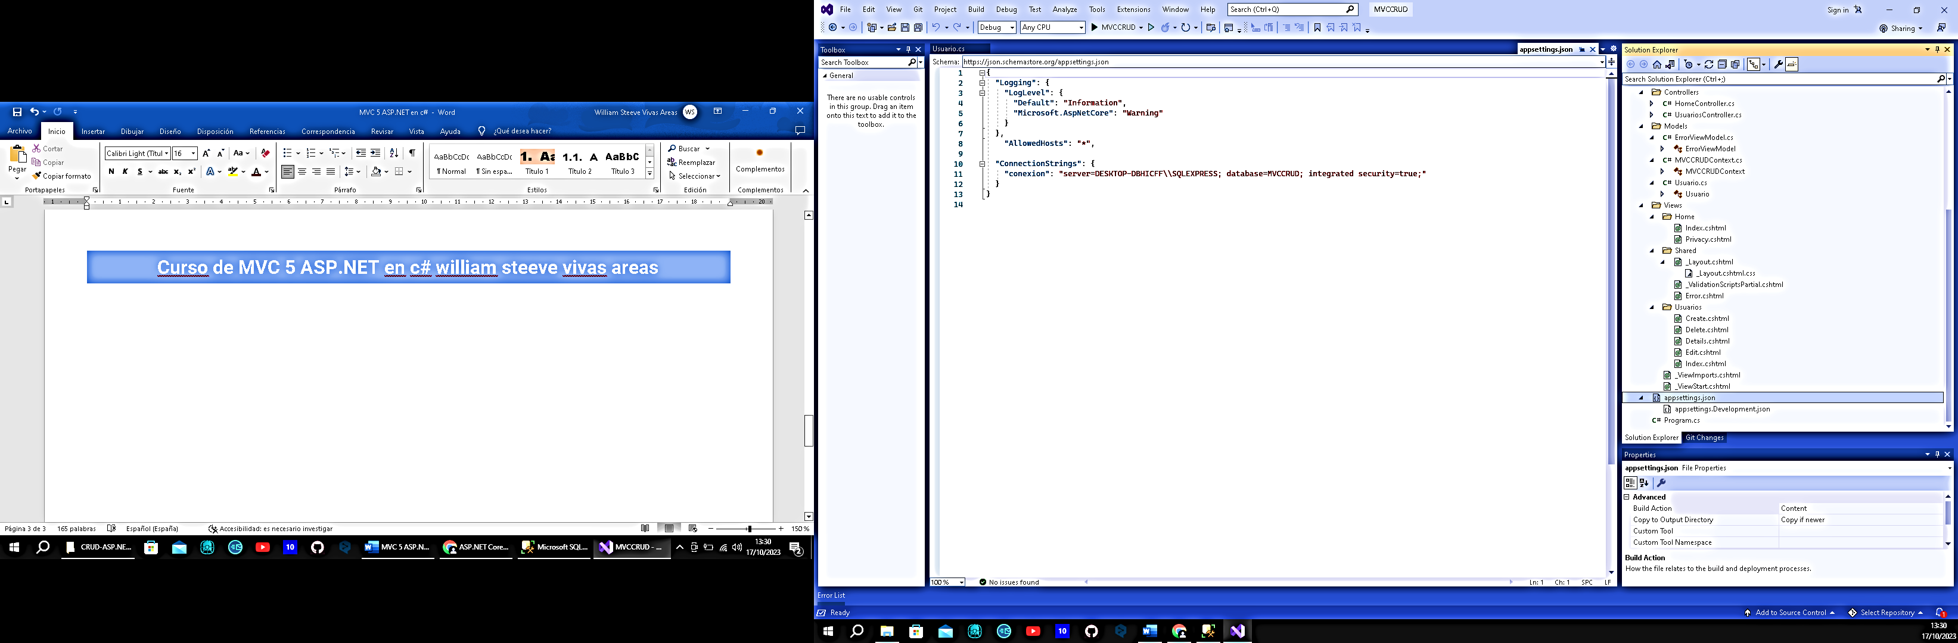

C:\1) PROGRAMAS & CURSOS\1) PROGRAMAS\CURSOS NUEVOS\2.1) MVC 5 ASP.NET en c#\CRUD-ASP.NET-CORE-MVC-.NET-6-master\MVCCRUD.sln

